HW2 -Part7

* appendToFile

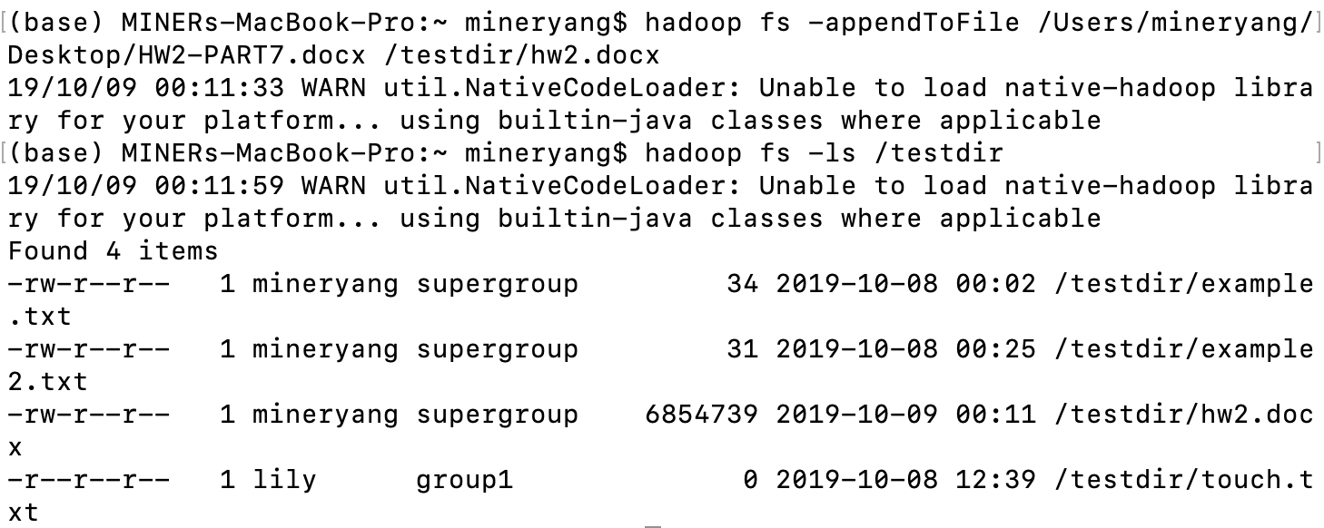

* cat

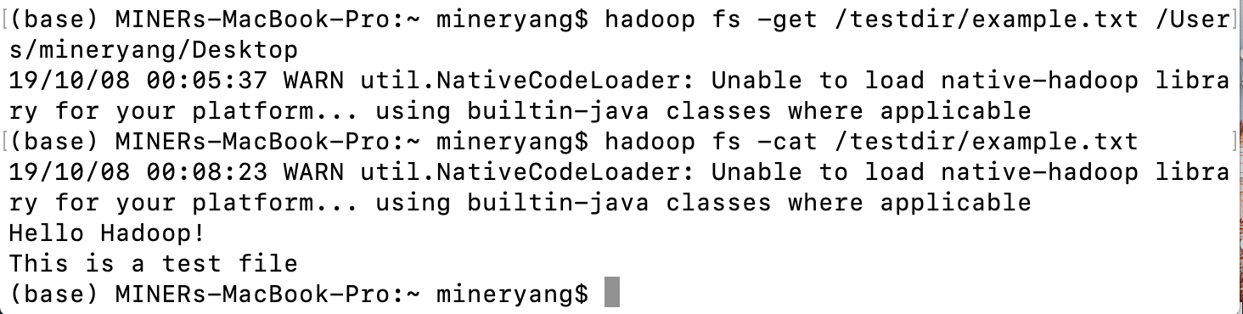

* checksum

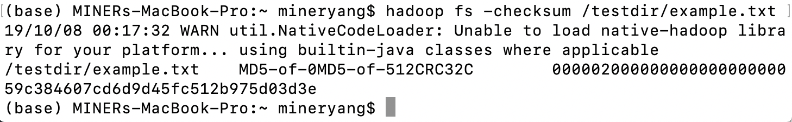

* chgrp

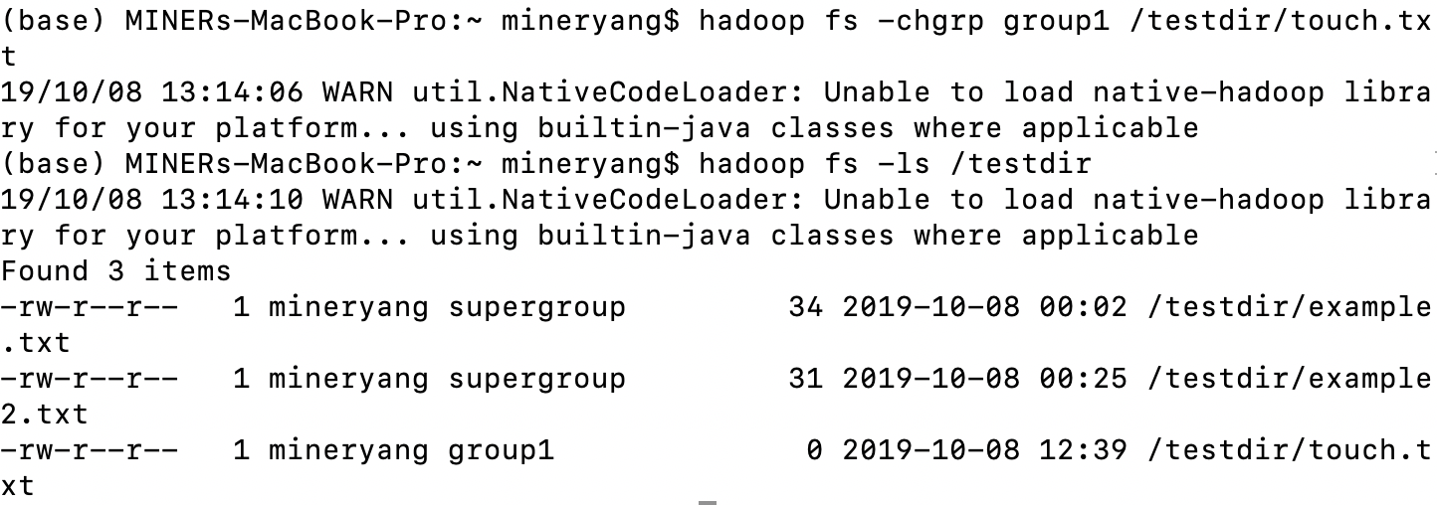

* chmod

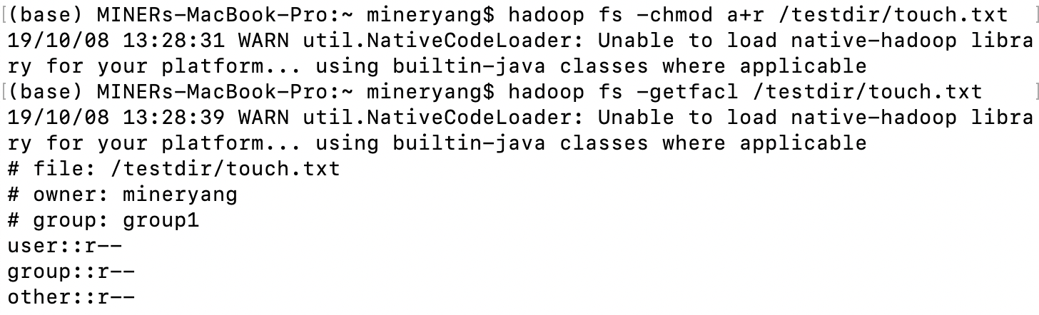

* chown

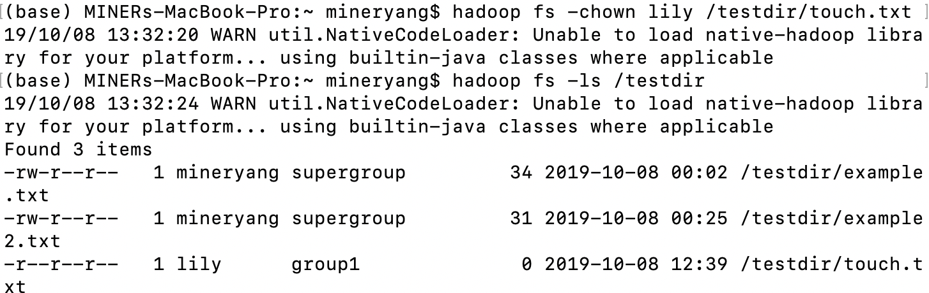

* copyFromLocal

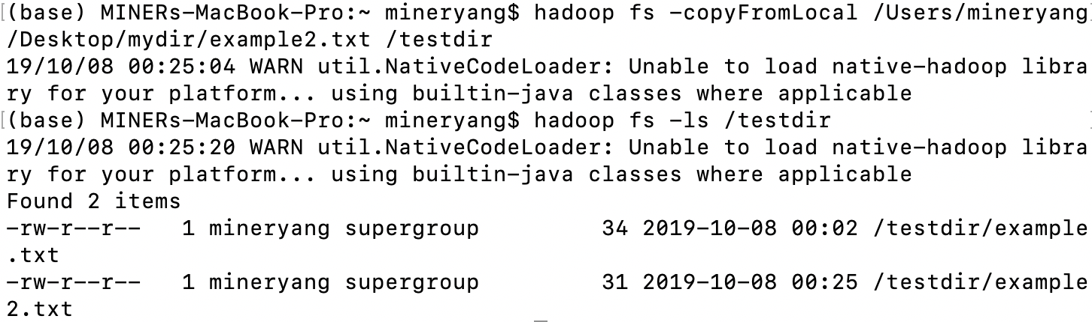

* copyToLocal

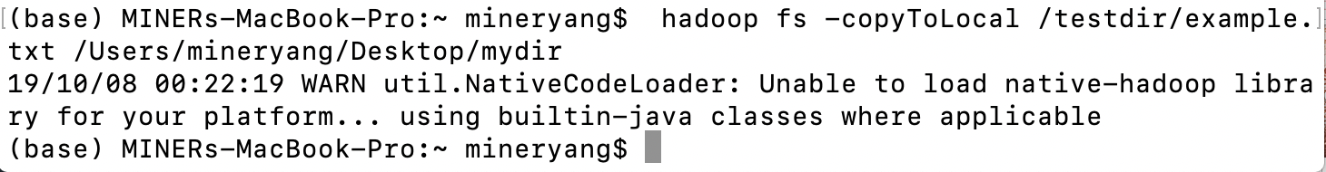

* count



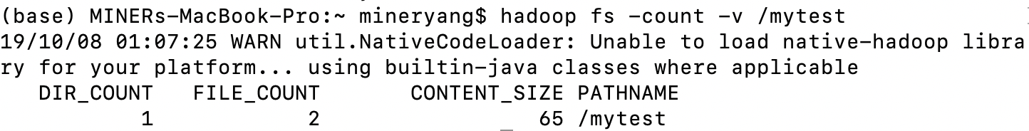

* cp

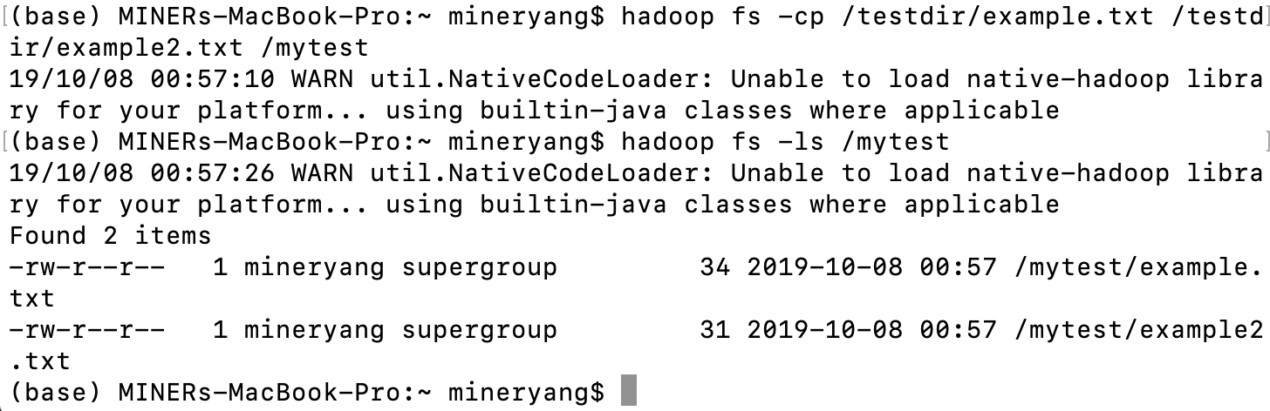

* createSnapshot

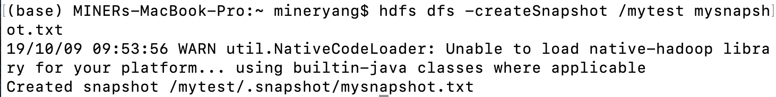

* deleteSnapshot

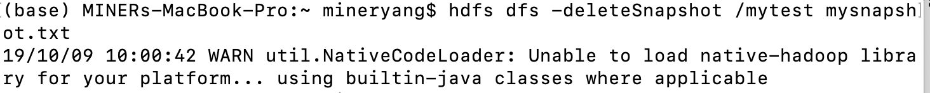

* df

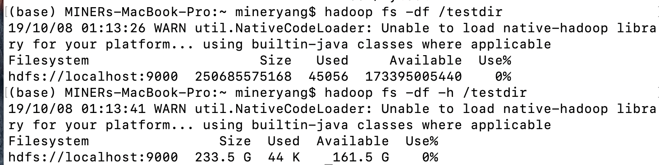

* du

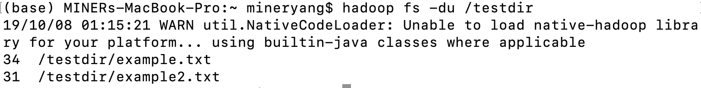

* dus

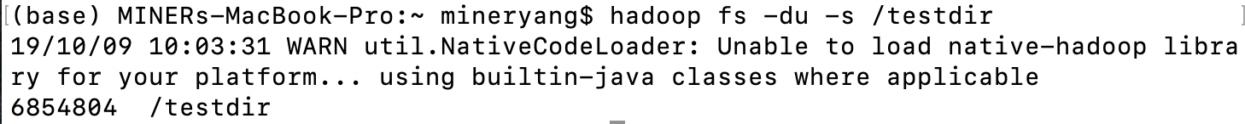

* expunge

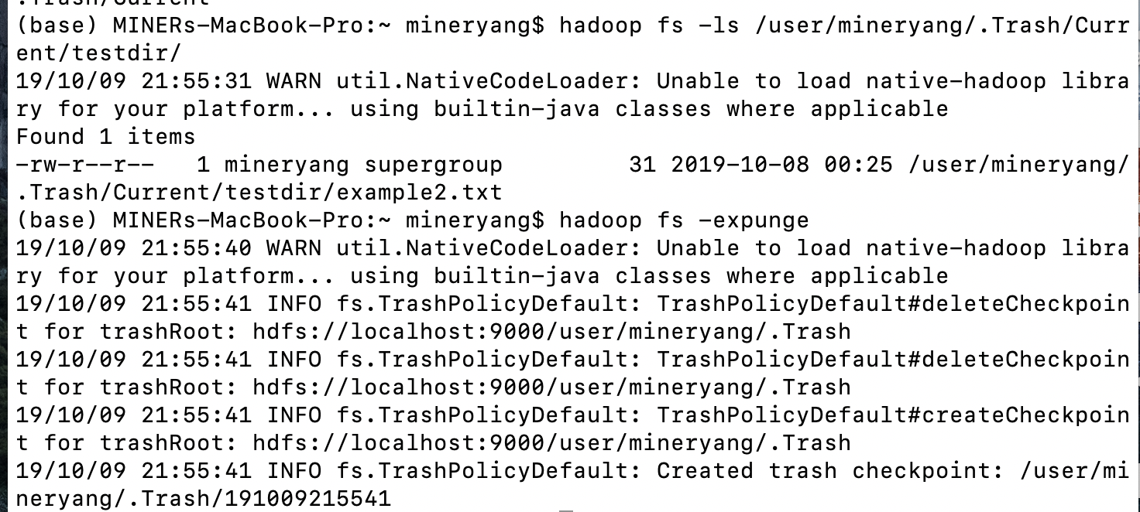

* find

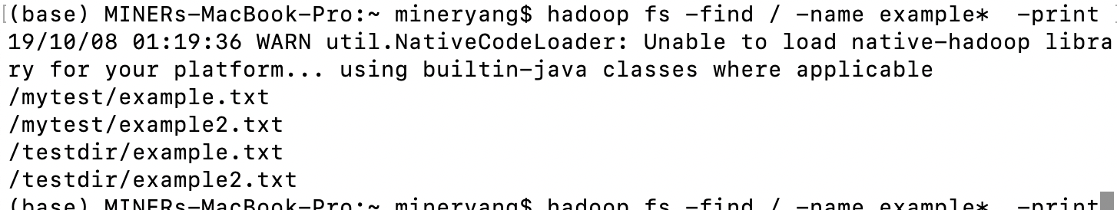

* get

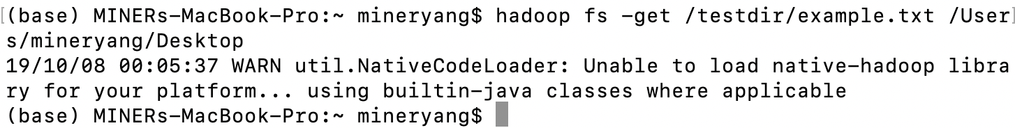

* getfacl

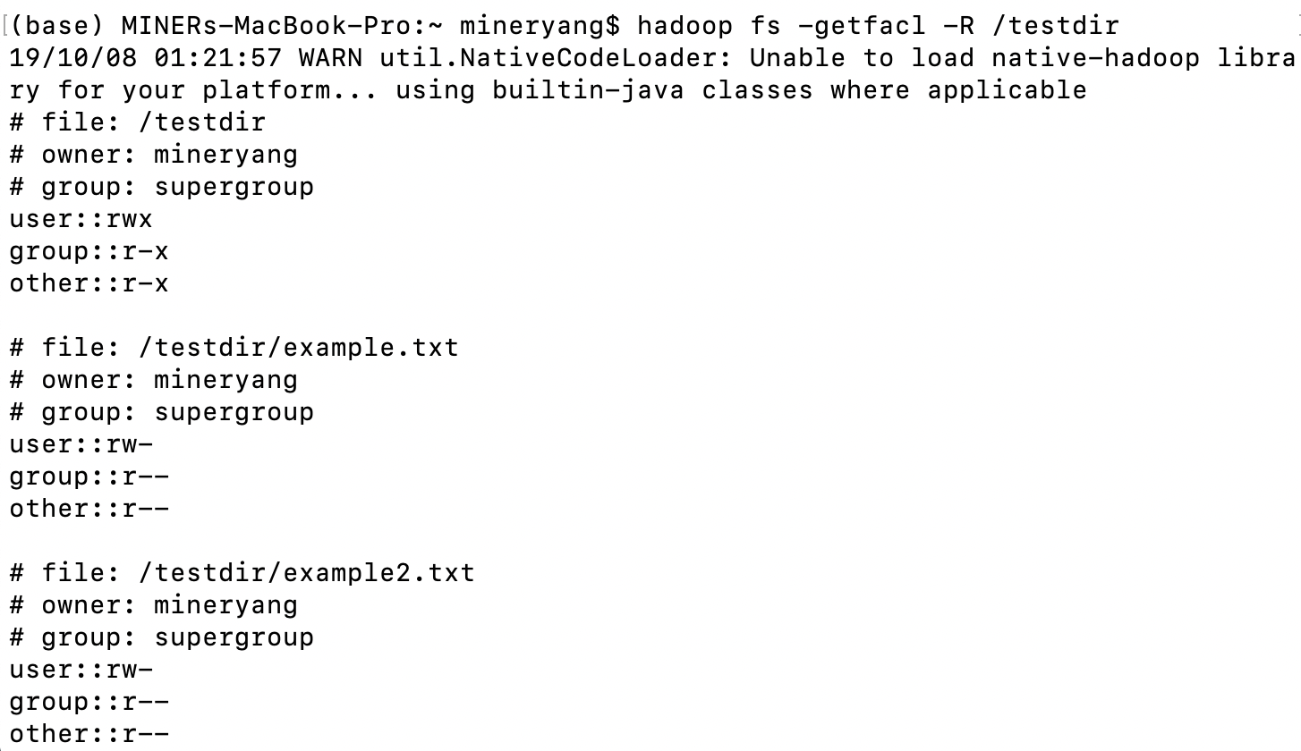

* getfattr

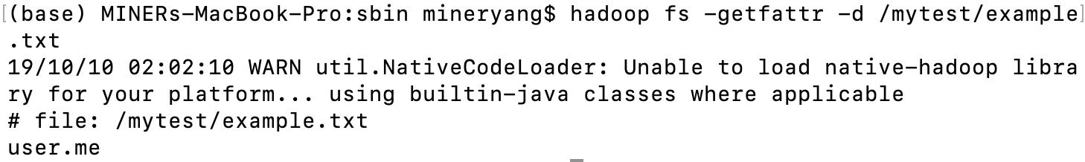

* getmerge

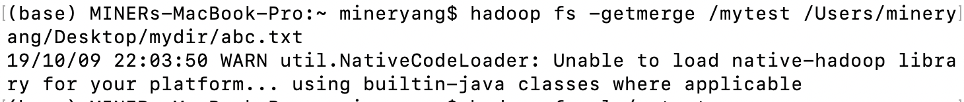

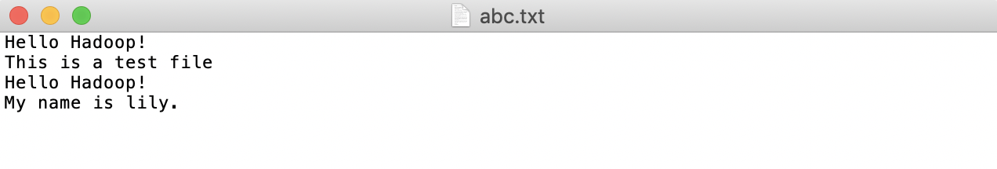

* help

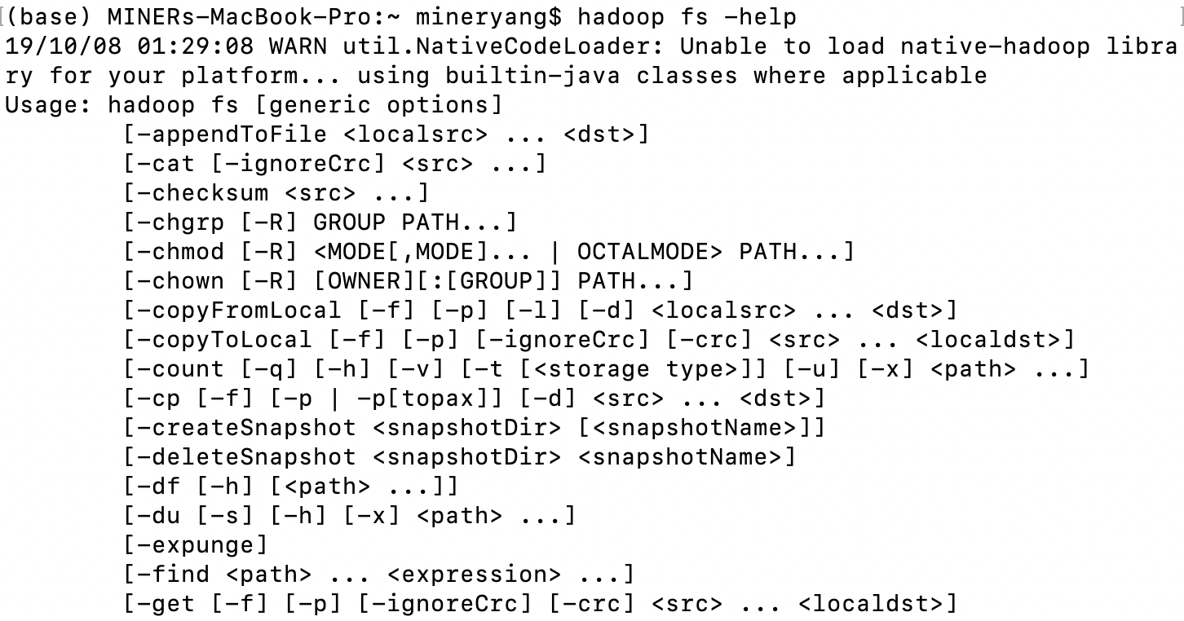

* ls

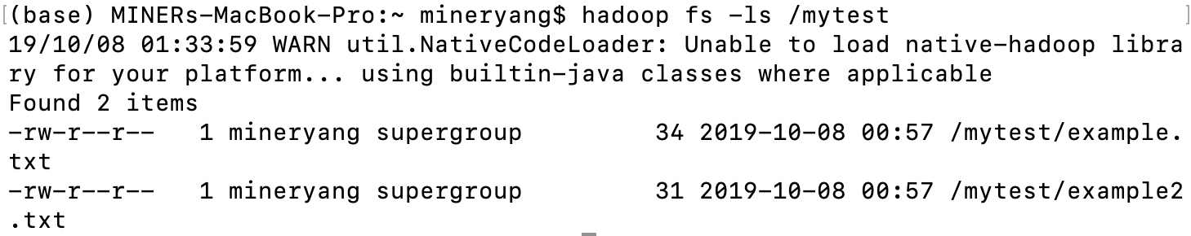

* lsr

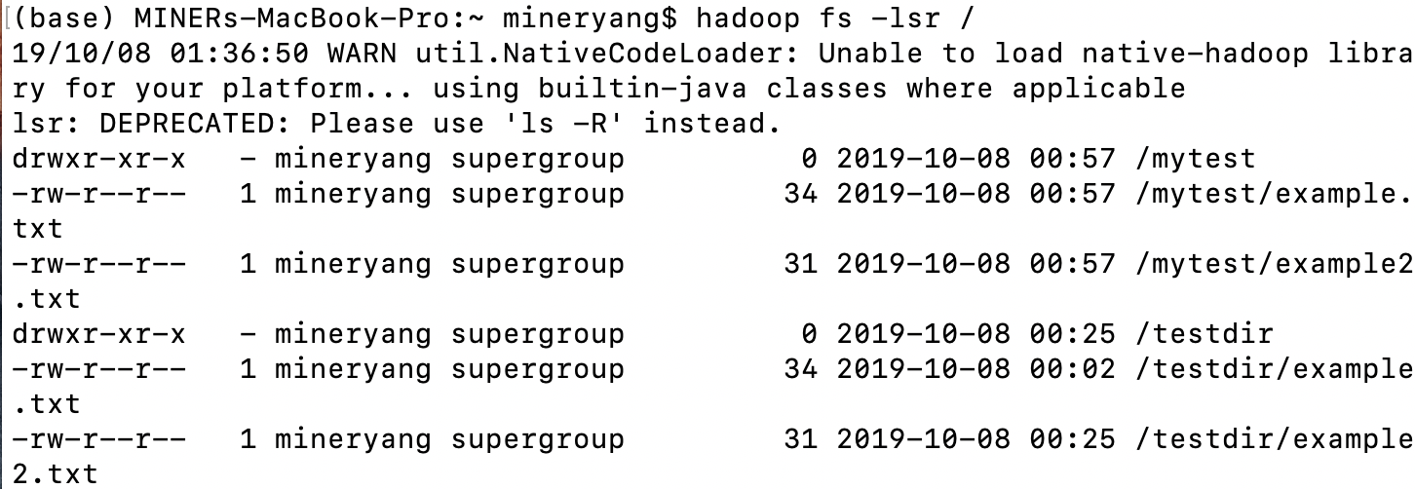

* mkdir

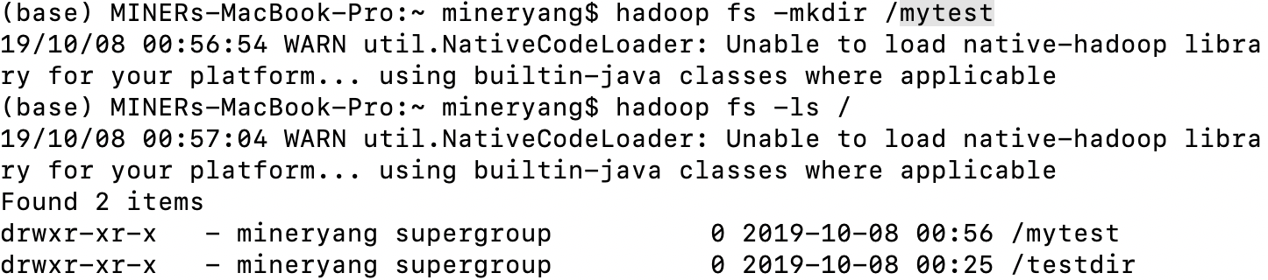

* moveFromLocal

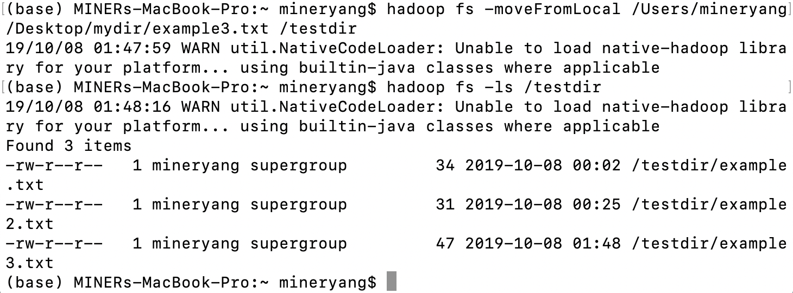

* moveToLocal

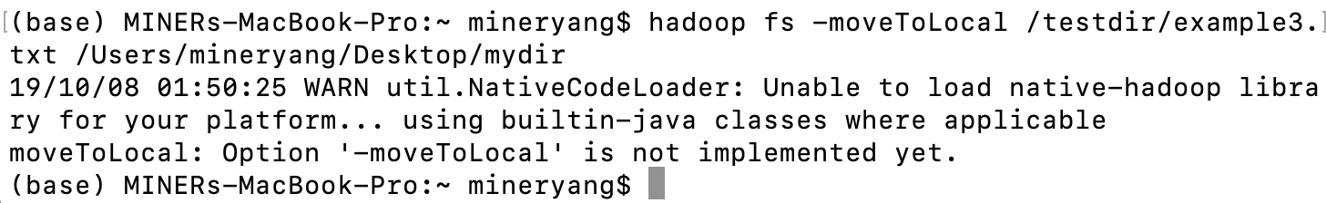

* mv

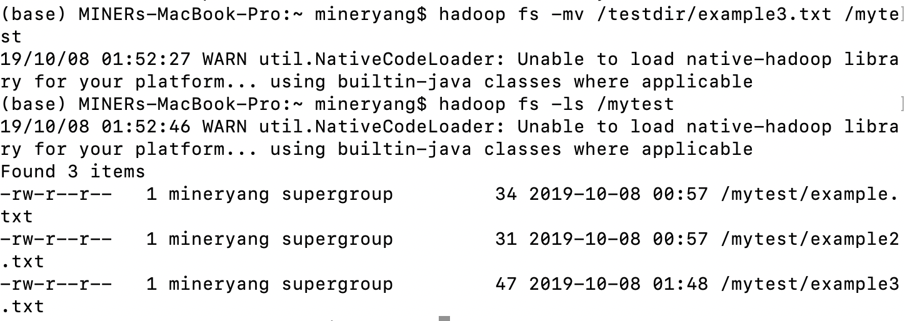

* put

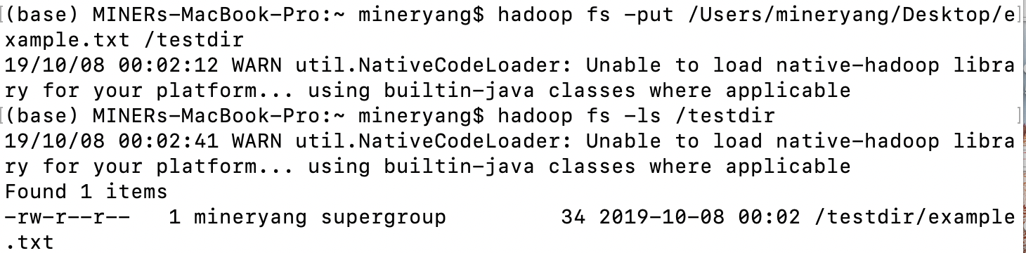

* renameSnapshot

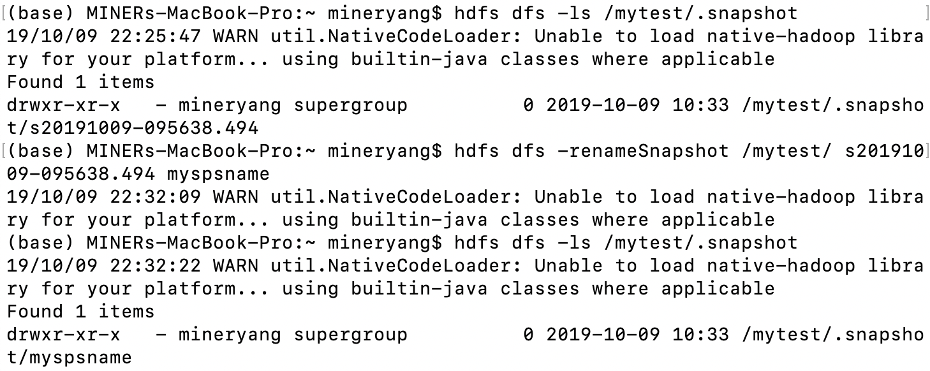

* rm

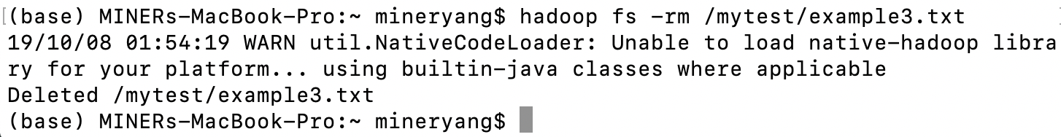

* rmdir

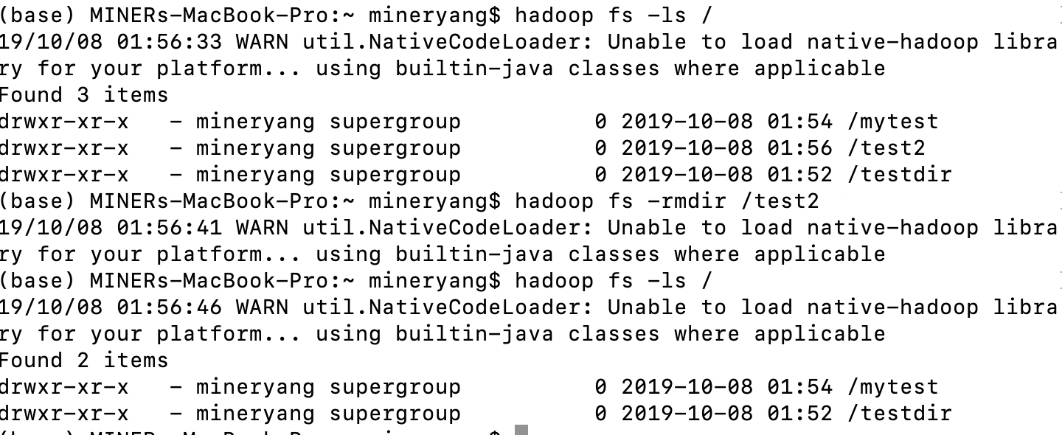

* rmr

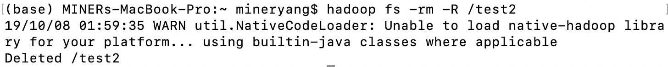

* setfacl

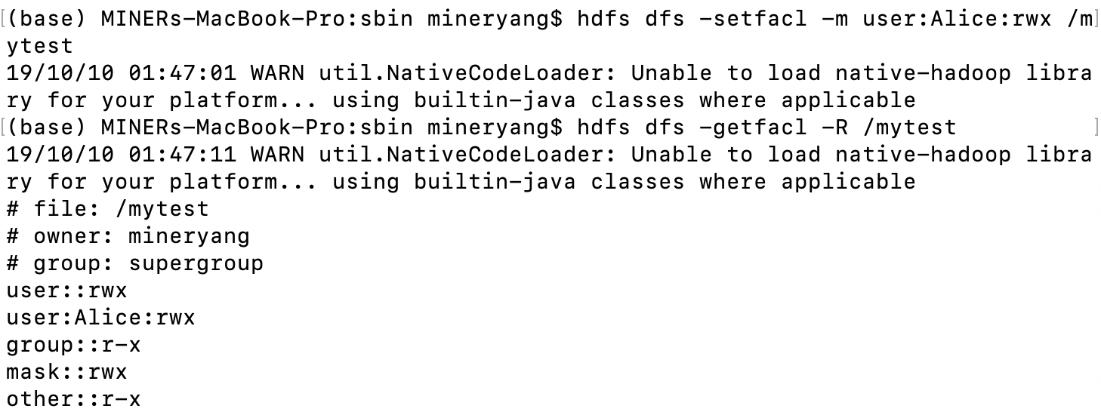

* setfattr

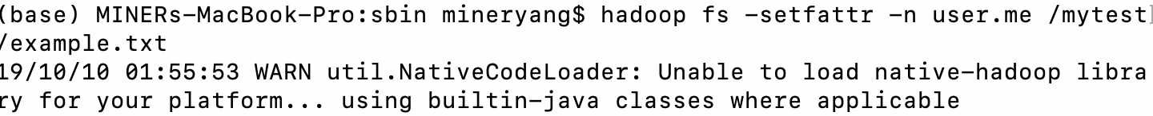

* setrep

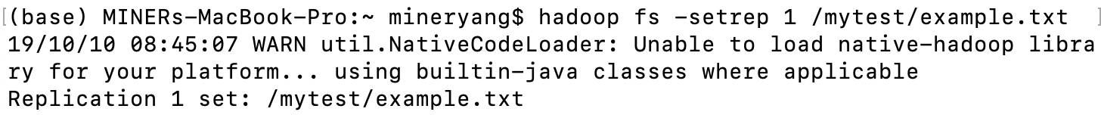

* stat

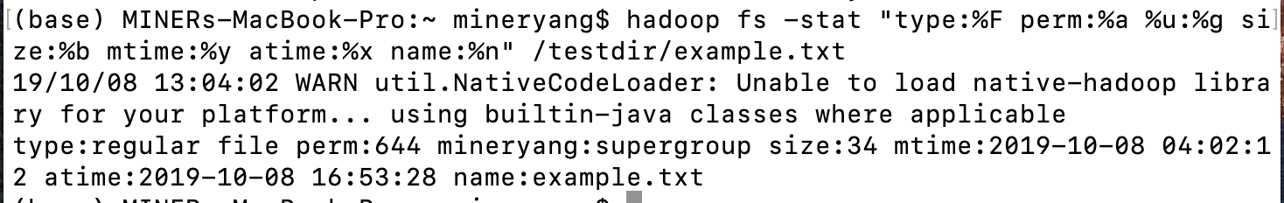

* tail

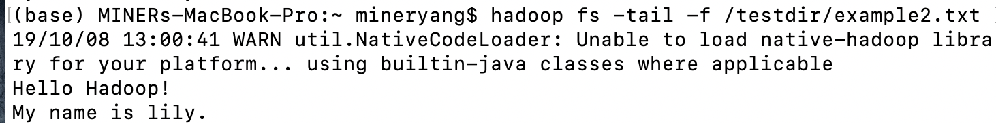

* test



* text

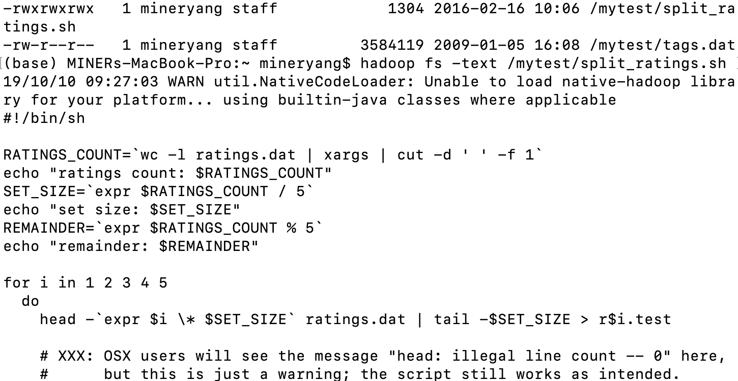

* touch

// not exist in the Hadoop 2.9.1

* touchz

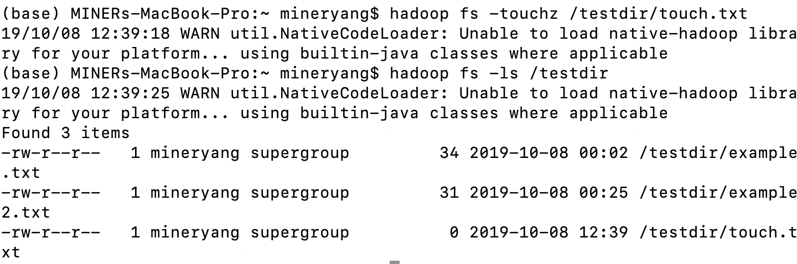

* truncate

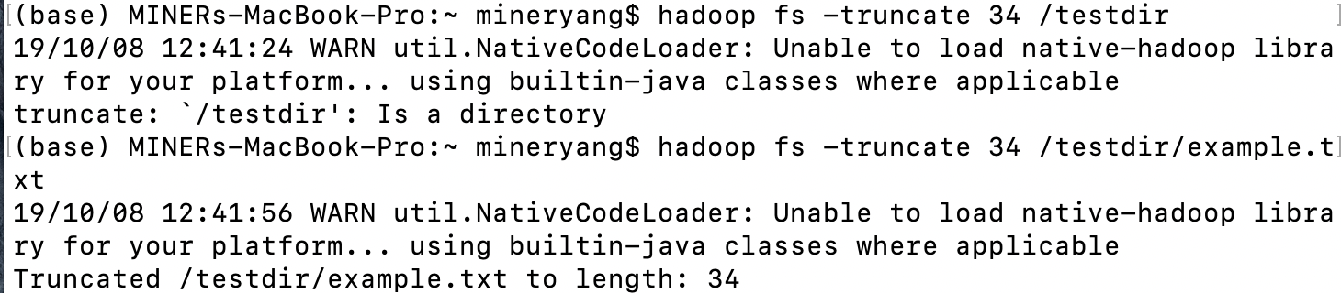

* usage

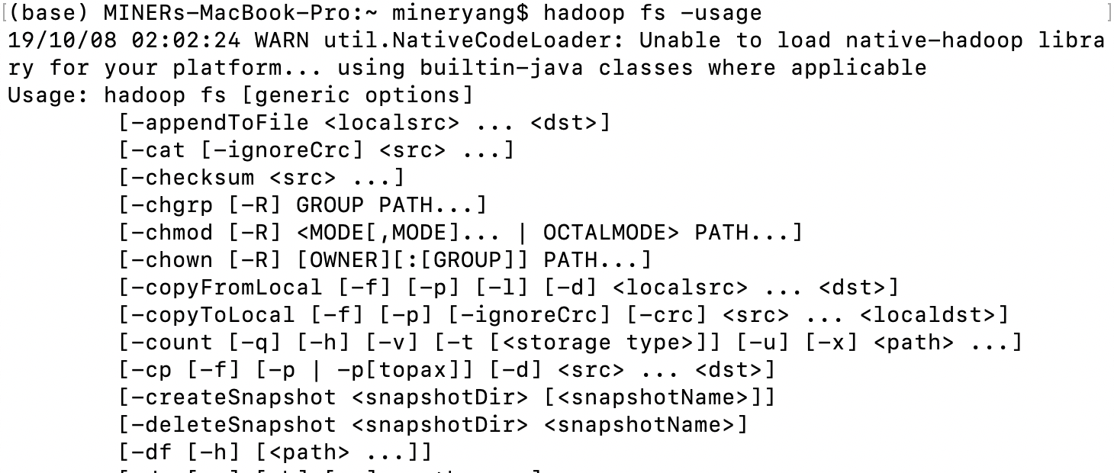

* Deleting objects

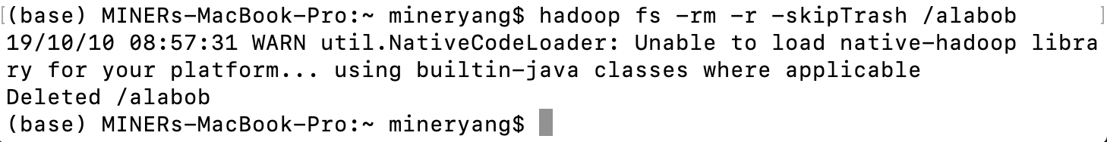

* Overwriting Objects

//

* Timestamps

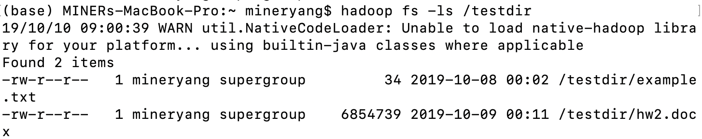

* Security model and operations

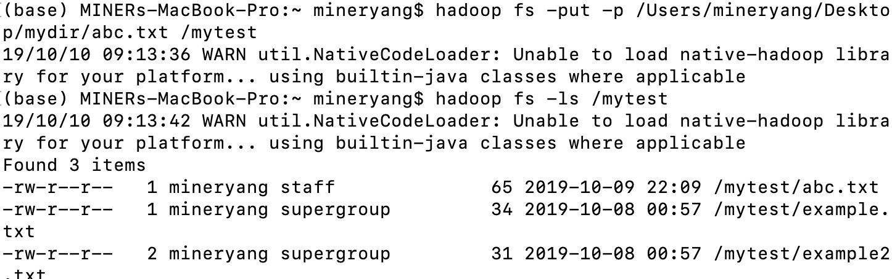

* Commands of limited value

//